Paper Format for the Proceedings of the 9th International Symposium on Management of Technology

Chen Jin^{1,2}，Mei Liang^{1,2}
1 School of Economics and Management, Tsinghua University, P.R.China, 100084
2 Research Center for Technological Innovation, Tsinghua University, P.R.China, 100084

Abstract: These instructions give you basic guidelines for preparing papers for the ISMOT’2019 Proceedings. Submitted papers should be 4 pages at least. Papers must be submitted using this format. This document is a template for Microsoft Word. If you are reading a paper version of this document, please download the electronic file from the Conference website, so you can use it to prepare your manuscript. Abstract should not exceed 200 words. Keywords should be in alphabetical order of the first letter of the beginning word, separated by commas.
Keywords: Font, Format, Margins

1 Introduction

Please prepare your paper using a A4 page size of 210mm × 297mm. Set the row spacing in paragraph menu as single row spacing. Indent paragraphs by 4 characters. There should be one blank line above and below each section title, while only one blank line above the subheading. All figures, tables, and equations must be included in-line with the text. Do not use links to external files.

2 Methodology

2.1 Format
In formatting your page, set top margin to 25mm and bottom margin to 31mm. Left and right margins should be 20mm. Page header should be 13mm and page footer should be 20mm. In document gridding menu, choose no gridding. Use a two-column format where each column is 21.95 characters wide and spacing 2 characters.

Tab.1 Type size and typeface for papers
Type Size (pts) | Appearance
Type Size (pts) | Times New Roman | Times New Roman Bold
9 | Figures, tables | Figure captions, table names
10 | Main text, equations, references | Subheadings
12 | Authors’ names | Section titles
14 |  | Paper title
2.2 Type sizes and typefaces
Try to follow the type sizes and typefaces specified in Tab. 1 as best as your can. The whole paper should use Times New Roman font. Use 14 point bold characters for the paper title, and capitalize the first letter of each substantive in the title. Author names should use 12 point characters and separated by commas. Capitalize the surnames and the first letters of the first names. Use a hyphen between first names. Use superscript on the right if authors’ sequence numbers are necessary. Use 10 point characters for the main text and author’s affiliations, please be sure that there are sequence numbers in front of them and add “P.R.China, zip code” at the end. Capitalize the first letter of the beginning word for each section title and subheading. Use 12 point bold Roman characters for section titles and 10 point bold Roman characters for subheadings.

3 Results

3.1 Figures and tables
Position figures and tables at the tops and bottoms of columns. Avoid placing them in the middle of columns. Large figures and tables may span across both columns.
Use 9 point characters for figures and tables, bold characters for figure captions and table names. Capitalize the first letter of the beginning word of each figure caption and table name.
Leave one blank line between the table name and above main text. Place the table name above the table, using the abbreviation “Tab”, such as “Tab.1”. Use the abbreviation “Tab.1” if you want to refer the table in the text.

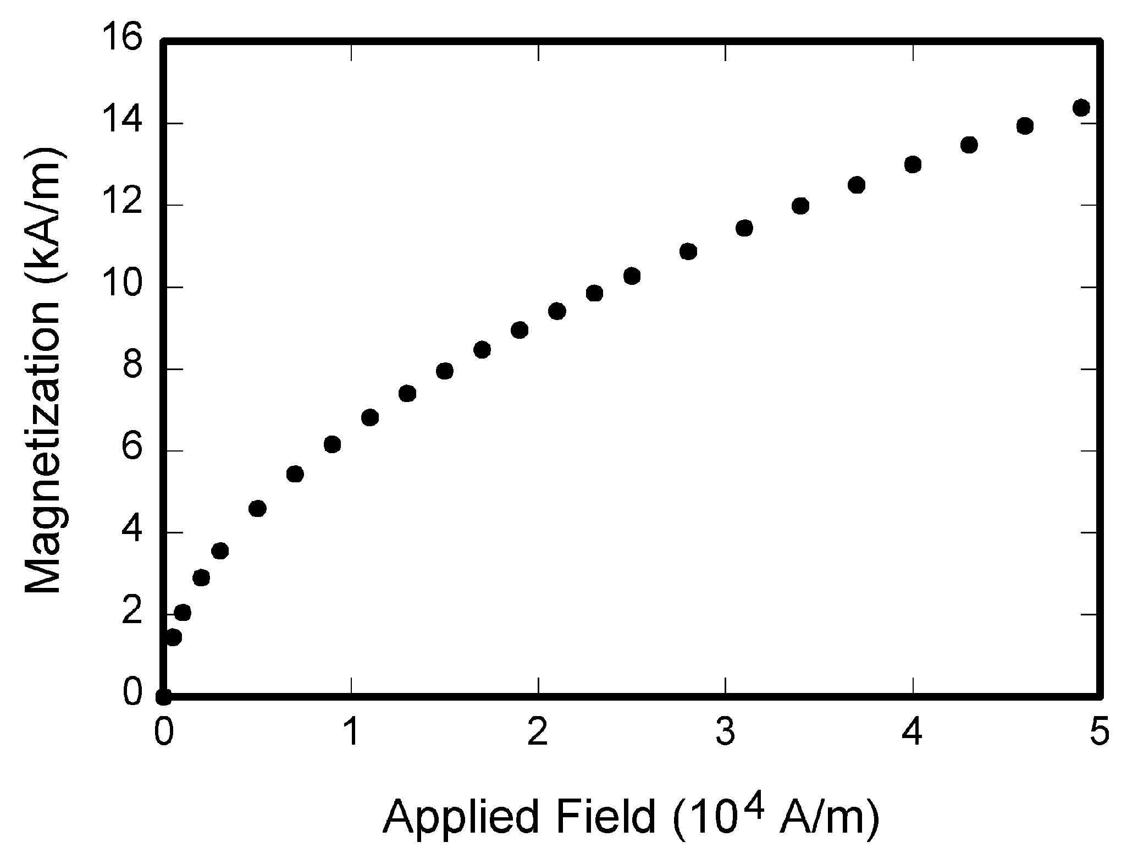
Fig. 1 Magnetization as a function of applied field
Try to use the drawing tool provided by Microsoft Word. For those which cannot be done by Word, please do not include the figure name. The figure name should be typed in Word alone. In order to be sure of the legibleness of the paper, please do not use color and gray scale image to express different meanings, as we adapt concolorous printing.
Figure caption should be below the figures. Use the abbreviation “Fig”, even at the beginning of a sentence, such as “Fig.1”. Leave one blank line between figure caption and the text below.

3.2 References
Number citations consecutively in square brackets [1]. Punctuation follows the bracket [2]. Refer simply to the reference number, as in [3]. Use “Ref. [3]” or “Reference [3]” at the beginning of a sentence: “Reference [3] was the first…”
Give all authors’ names; do not use “et al.” unless there are six authors or more. Papers that have not been published, even if they have been submitted for publication, should be cited as “unpublished” [4]. Papers that have been accepted for publication should be cited as “in press” [5]. In a paper title, capitalize the first word and all other words except for conjunctions, prepositions less than seven letters, and prepositional phrases.
For papers published in translation journals, please give the English citation first, followed by the classification of the original foreign-language in parentheses [6].

3.3 Abbreviation and acronyms
Define abbreviations and acronyms the first time they are used in the text, even after they have already been defined in the abstract. Abbreviations such as IEEE, SI, MKS, CGS, ac, dc, and rms do not have to be defined. Abbreviations that incorporate periods should not have spaces: write “C.N.R.S.,” not “C. N. R. S.” Do not use abbreviations in the title unless they are unavoidable.

3.4 Equations
Please use equation tools provided by Microsoft Word to edit your equations. Number equations consecutively with equation numbers in parentheses flush with the right margin, as in (1).
A + B = C (1)
Be sure that the symbols in your equation have been defined before the equation appears or immediately following. Italicize variables.

3.5 Other recommendations
Number the section titles using Roman numerals. The type size and typeface of Introduction and References are the same as section titles. Number Introduction, but not References. References should be placed in the middle of column. The section titles and subheadings should be at the margin. Type a space after a period or a colon.
Use a zero before decimal points: “0.25,” not “.25.” Use “cm³,” not “cc.” Indicate sample dimensions as “0.1 cm × 0.2 cm,” not “0.1 × 0.2 cm².”
4 Conclusion

Finally, you are responsible for language as experts or editors will not check it. Do a spell and grammar check. This is available in Word. If English is not your native language, get a professional proof-reader to help if possible.
Prefixes such as “non,” “sub,” “micro,” “multi,” and “ultra” are not independent words; they should be joined to the words they modify, usually without a hyphen.
Sponsor and financial support acknowledgments are placed in the unnumbered footnote on the first page.

References

[1] D. J. Beebe, Signal conversion (book style with paper title and editor) in biomedical digital signal processing, W. J. Tompkins, Ed. Englewood Cliffs, NJ: Prentice-Hall, 1993, ch. 3, pp. 61–74.
[2] M. Akay, time frequency and wavelets in biomedical signal processing (book style). piscataway, NJ: IEEE press, 1998, pp. 123–135.
[3] G. B. Gentili, V. Tesi, M. Linari, and M. Marsili, A versatile microwave plethysmograph for the monitoring of physiological parameters (Periodical style), IEEE trans. biomed. eng., vol. 49, no. 10, pp. 1204–1210, Oct. 2002.
[4] V. Medina, R. Valdes, J. Azpiroz, and E. Sacristan, title of paper if known, unpublished.
[5] E. H. Miller, A note on reflector arrays (periodical style—accepted for publication), IEEE trans. antennas propagat., in press.
[6] T. Menendez, S. Achenbach, W. Moshage, M. Flug, E. Beinder, A. Kollert, A. Bittel, and K. Bachmann, Prenatal recording of fetal heart action with magnetocardiography (in German), Zeitschrift für Kardiologie, vol. 87, no. 2, pp. 111–8, 1998.

